2/11/2018

Lau Ki Lai

Ch3 clutter is your enemy

Clutter: one culprit that can contribute to excessive or extraneous cognitive load is something.

These are visual elements that take up space but don’t increase understanding.

Take more specific look at exactly what elements can be considered clutter soon, but in the meantime I want to talk generally about why clutter is a bad thing.

Gestalt Principles of Visual Perception: When it comes to identifying which elements in our visuals are signal

(the information we want to communicate) and which might be noise

(clutter).

Six principles:

Proximity, similarity, enclosure, closure, continuity, and connection.

Lack of visual order

The impact visual order-and lack thereof-can have our visual communications.

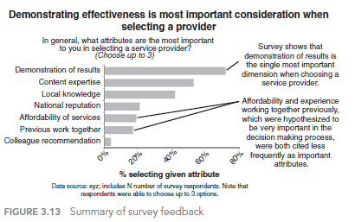

Alignment

White space

White space in visual communication is as important as *pauses* in

public speaking.

Non-strategic use of contrast

Clear contrast can be a signal to our audience, helping them understand

where to focus their attention.

Decluttering:

Step-by-step

Six major changes:

1. remove chart
2. Remove gridlines
3. Remove data markers
4. Clean up axis labels
5. Label data directly
6. Leverage consistent color

In closing

Clutter is

your enemy: ban it from your visuals!

Chapter4

3 memory:

-iconic memory

-short-term memory

-Long-term memory

You need to point out what you want the audience to see.

Used different size and colors to point out the main point

That will make the audience attentions.

Ch5

Think like a designer

Highlight the important stuff

Eliminate distractions

create a clear visual hierarchy of information

Don’t overcomplicate

- Make it legible

- keep it clean

- use straightforward language

- Remove unnecessary complexity

Text is your friend

Aesthetics

-be smart with color

-pay attention to alignment

-leverage white space

Acceptance

- articular the benefits of the new or different approach

-show the side-by-side

-provide multiple options and seek input

-got a vocal member of you audience on board

Ch6

Model visual 1: line graph

Model visual 2 : annotated line graph with forecast

Model visual3: 100% stacked bars

Model visual 4:leveraging position and nagative stacked bars

Model visual 5: horizonal stacked